T.R.E.A.T.S
Welcome

Newsletter
August-October 2009

Scottish Charity No SC 024468
Telephone 01847 893000
treatschildcare@hotmail.co.uk Web page www.spanglefish.com/treats
General Information
Staff
As we are always trying to improve or services, we now have a new organizational chart up in the treats room, this will help any new parents be aware off staff job titles.
Julie MacDonald- Team Leader
Ann Thomson- Senior Playworker
Gail Malcolm –Senior Playworker
Pauline Mather- Assistant playworker
Nicola smith-Assistant playworker
Kay Nestor-Assistant playworker
Abigail Mellor- Relief Assistant playworker
Louise Furniss- Finance
Lisa MCkellar – Administrator/bills

Ann & her partner are delighted to share with us their great news! Ann is expecting their first child in January. Ann has been unwell with various ongoing problems with her health, but would like to assure us that she and the baby are doing well & we wish her all the best.

Redecoration
The children have requested a fresh lick of paint in the treats room; this in time will go with the new carpet that we hope to afford very soon (waiting for quotes). Any parents, grandparent or professional that is willing to lend a painting hand please speak to Julie MacDonald.
Booking Forms

We now have our holiday Booking Form which will need completion. We appreciate that it is often difficult to know exactly when you will need our facilities however some forewarning of your requirements will help us when organising our Playworkers.
Please complete these and return as soon as possible.
If you have to make changes – this is fine – just give us a call and leave a message either on 893000 or our mobile 07554671613 any messages not picked up immediately will be diverted to the treats mobile and staff on call, will pick them up day or night
 Registration Forms

There are still a number of parents who have yet to return the Registration forms mailed out recently – it is vital that we receive these as soon as possible and would be grateful if you would return your forms. Please remember if you have changed your mobile number or emergency contact numbers, staff must be informed.
Training

Our current staffs are constantly updating their knowledge and have attended a number of courses held within the local area to advance their skills: these have included a First Aid course, Behaviour management skills food Hygiene and others. This is ongoing and we hope to attend as many of the local seminars and courses organised by the Out of School Care Federation and Highland Childcare Partnership as possible.

Summer Holiday Period

Treats went on a number of day trips during the holidays, some trips were joined by Casper Club, where both groups enjoy getting to know one other.

Orkney

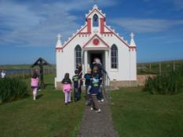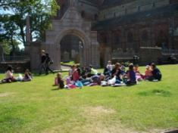

Children from Casper, Treats, Wick Family & Ormlie centre participated and enjoyed the lovely weather. All the children enjoyed the water slide, water games, balloons and Bouncy Castle
To top it all off – Ormlie Centre won and were awarded with the It’s a Knockout Cup!
Well done to everyone involved.

It’s a knock out

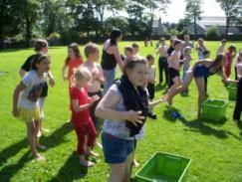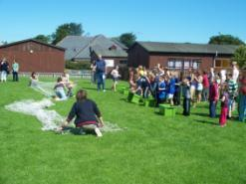

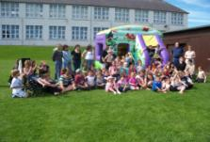

Other activities also took place over the 6 weeks. The children attended day trips to Dunnet Forest, for Den making, Scavenger Hunt, Dunnet Beach for BBQ and Pirate treasure hunt day at Thurso boating pond

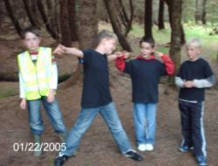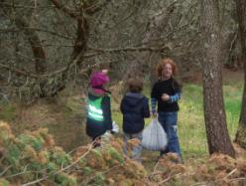

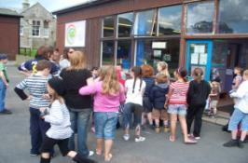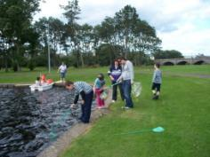

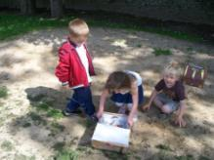

October Holidays

TREATS will be open on Friday the 9th October- Thursday the 29th October 2009, the holiday club provides a sufficient amount of activities, outings and day trips. We are available from 7am-6pm. All children must be booked in.

Halloween Party

TREATS Halloween Party will be held on Wednesday the 28th October in Dunnet Forest.

You are invited to join Treats and Casper club for a haunted experience in the forest if you dare!!
You will require to dress-up (you could be in for a chance for winning 1st prize for fancy dress) we would appreciate an item of pre-packed food to help towards feeding our hungry ghost, witches& ghouls.
Come join us in playing party games, ducking for apples, blood dripping pancakes, spooky hide &seek and much more.
I will see you there.

